

Managing Digital IDs
Q-0006
Revision A

Revision History
Rev | Status | Date | Author | CO # | Description
A | Draft | 2/9/05 | SLB |  | Initial Release

Training
Role | New | Trained in previous rev.
Document Coordinator | Read the document | Not applicable for Rev A
Document Author | Read the document | Not applicable for Rev A
Record Signer | Read the document | Not applicable for Rev A

Purpose
Electronic signatures allow personnel to certify and approve contents of documents and records. Electronic signatures are used because MedCommons personnel are geographically dispersed and the MedCommons document and record control systems are electronic. MedCommons has chosen to use the digital signature capabilities within Adobe Acrobat Standard, which complies with 21 CFR Part 11. (See http://www.adobe.com/support/techdocs/1a546.htm for information from Adobe regarding compliance.) In order to utilize this feature of Acrobat, it is necessary to properly manage digital IDs.

Scope
This process applies to most MedCommons documents and records. These may include, but are not limited to, documents regarding MedCommons policy, processes, procedures, and records. Procedure-specific automated systems may have their own electronic signature capabilities. If so, the MedCommons document describing the procedure will describe the capabilities and how they are used.

Responsibilities

Document Coordinator
The Document Coordinator oversees document and record processing. The Document Coordinator provides assistance in creation and distribution of digital IDs and certificates and maintains archival files of certificates.

Record Signers
Personnel create a digital ID and certificate and distribute the certificate to the Document Coordinator and others who may need to validate this signature.

When personnel sign a record, such as a Change Order, they apply the digital signature per procedure Q-0028 Electronic Signature Process.

Records created
Digital signature certificates are created by the signers. A copy is sent to the Document Coordinator who retains it in the certificate archive.

Related Documents

- Q-0002 Document Control
- Q-0003 Control of Records
- Q-0028 Electronic Signature Process

Procedure

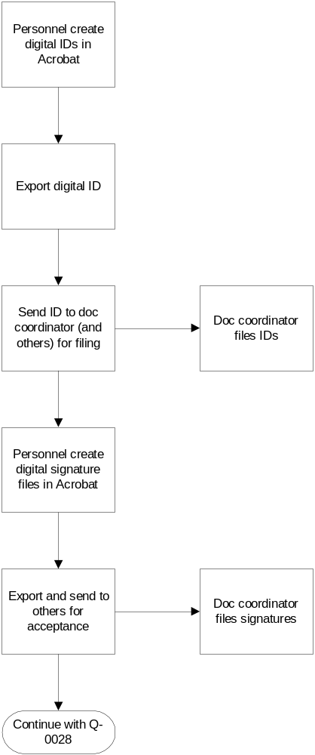

First: Ensuring Password Prompt on Signing
- From within Adobe Acrobat Standard 6.0, select Edit>>Preferences.
- Click on Digital Signatures.
- Set the signing method to be Default Certificate Security.
- Click on OK.

Creating a digital ID and signature certificate
- From within Adobe Acrobat, select:
Advanced>>Manage Digital IDs>>My Digital ID Files>>Select My Digital ID File. (If another digital ID is open, this command changes to Open Another Digital ID File.)
- Click New Digital ID File, and then click Continue.
- In the Create Self-Signed Digital ID dialog box:
  - Type a name for your digital ID. When you certify or sign a document, this name appears in the Signatures panel and in the signature field.
  - Do not select Unicode Support.
  - Choose 1024-bit RSA
  - Specify you want to use the digital ID of digital signature.
  - Type a password containing at least six characters. Type the same password in both the Choose a Password and Confirm a Password text boxes. Passwords are case-sensitive.
- Click Create, specify a file name and location, and then click Save.
Important: Make a backup copy of your digital ID file. If your digital ID file is lost or corrupted, or if you forget your password, you cannot use that profile to add or validate signatures.
- Export and send your digital ID certificate file to the Document Coordinator and others who need to validate your signature.
- Confirm that you will be asked for your password when signing a document by:
  - Choosing Advanced>> Manage Digital IDs>>My Digital ID Files>>My Digital ID File Settings. If you are asked for your password, enter it. (You are not asked if you already opened the Digital ID File.)
  - On the Digital ID File Settings screen, be sure your Digital ID File is highlighted. Click on Password Settings.
  - The Password options should be:
    - Check Require password is to access when signing.
    - The Always button is selected.
- If they, are you may click OK and exit. If not, make the changes and enter your password. Then click OK and exit.

